Case #1:
Teacher Products Inc. produces stars for elementary teachers to reward their students. Teacher Products’ trial balance on September 1 follows:
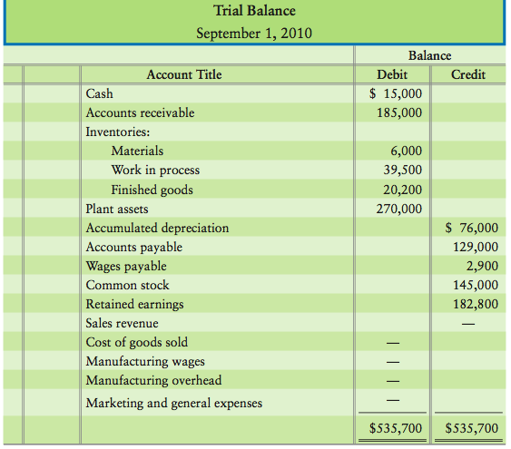
September 1 balances in the subsidiary ledgers were:
- Materials sub-ledger: $4,600 paper and $1,400 indirect
- WIP sub-ledger - job 120 $39,500; $0 for job 121
- Finished goods sub-ledger - $7,900 large stars and $12,300 small stars
September transactions are summarized as follows:
- Collections on account, $153,000
- Marketing and general expenses incurred and paid, $28,000
- Payments on account, $41,000
- Materials purchases on credit: paper, $4,600; indirect materials, $4,600
- Materials used in production (requisitioned):
    - Job 120: paper, $800
    - Job 121: paper, $7,650
    - Indirect materials, $1,800
- Manufacturing wages incurred during September, $37,000, of which $34,300 was paid. Wages payable at August 31 were paid during September, $2,900
- Labor time records for the month: Job 120, $3,700; Job 121, $18,800; indirect labor, $14,500
- Depreciation on plant and equipment, $3,300
- Manufacturing overhead was allocated at the predetermined rate of 80% of direct labor cost
- Jobs completed during the month: Job 120, 800,000 Large Stars at total cost of $46,960
- Credit sales on account: all of Job 120 for $105,000
- Closed the MOH account to COGS.
Requirements:
- Record the September transactions. Teachers Products uses a perpetual inventory system. Number the transactions.
- Prepare a trial balance at September 30.
- Prepare a Cost of Goods Manufactured Statement for September.
- Prepare an income statement for the month of September.

